Backout the changes from GIT:

1)To move the changes from stage Area to Unstaging area

**git reset HEAD Filename**

**To discard the changes in the working directory: git checkout – Filename**

**Delete File in GIT: git rm Filename**

**Delete multiple files : git rm -rf File**

**git init : To initialize the git repository in local**

**git remote add origin** <https://github.com/narayanabarnana/Selenium.git> : To sync the local repository with Centralized repository(GIT HUB Repository)

git pull : to pull the changes from the server(Central Repository GIT HUB)

git pull origin master: To specify the branch you want to merge with

git status

git add .

git commit -m “Added New files today”

git push origin master : TO push the changes to centralized repository

Branch commands

**Git branch branchname:** to add a new branch.

When we create a new branch , whatever the data in the master branch will copy to the new branch.

Switch from one branch to another branch: **git checkout branchname**

Once you create a branch execute the command git push origin master

To check the branches in your project : git branch

To check how many files in the branch : ls

Happy path merges in branch

To check local branch : git branch

Merge one branch to another branch: First switch to the merging branch i.e. the destination branch and execute the below command

Git merge sourcebranch

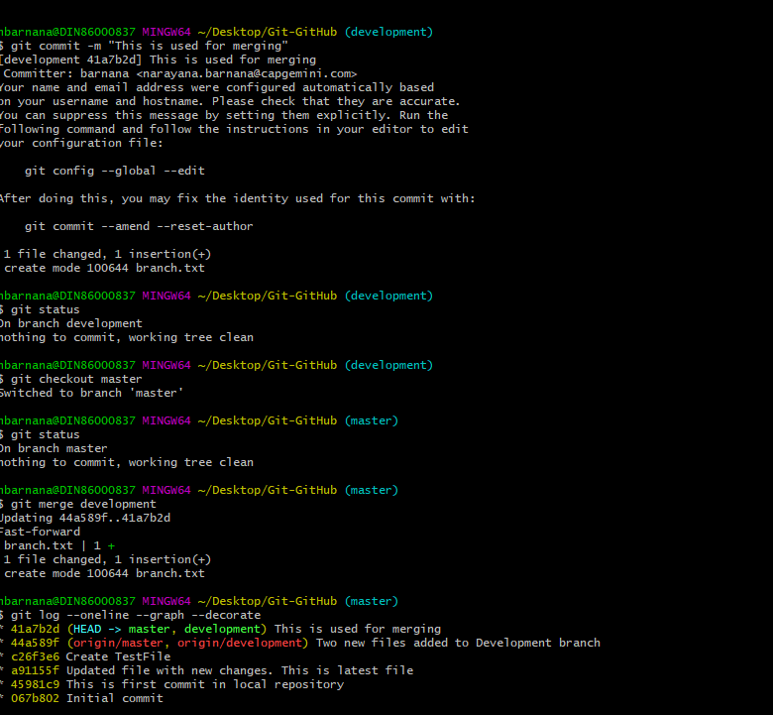

**Auto merge in GIT**

**Merge Conflicts in GIT**